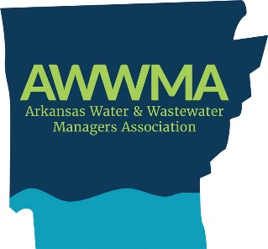

2026 AWWMA Scholarship Program

Application Deadline: July 13th
This program is for active AWWMA member utility employees and/or their dependents. The number of scholarship applications that your utility is eligible to submit will be equal to the number of current active AWWMA members at your utility, with a maximum of three (3) applications allowed.

Examples:
- If your utility has 1 active membership, you may submit 1 scholarship application.
- If your utility has 2 active memberships, you may submit 2 scholarship applications.
- If your utility has 3 or more active memberships, you may submit a maximum of 3 scholarship applications.

IMPORTANT:

The current year’s Utility Assessment must be up to date in order for employee application(s) to be considered valid. Only one application per member utility employee or dependent will be accepted for consideration by the Scholarship Committee.

Awards:

The annual scholarship award amount will range from $500.00 to $1,000.00.

Scholarship Eligibility Process

Eligible institutions include colleges, junior colleges, and vocational-technical (Vo-Tech) schools.

- Employees are not eligible for the AWWMA scholarship if their member utility reimburses their tuition costs for attending school.

Applications must be submitted by the utility and must include the utility's official stamp.

Applications submitted without the utility’s stamp will not be considered valid.

The Scholarship Committee must receive all applications by the deadline of July 13. Applications received after this date will not be considered.

Scholarship Drawing Details:

A total of ten (10) winners will be drawn at the AWWMA Annual Meeting.

Winners must submit proof of registration at an eligible school, postmarked no later than September 1st of the year they are selected, to receive scholarship funds.

Five (5) alternates will also be drawn at the Awards Banquet. If any winner fails to meet the eligibility requirements, an alternate will be selected in the order drawn to receive the scholarship.

Distribution of Funds:

Scholarship funds will be distributed to the selected recipients once proof of registration at an eligible school has been received and approved by the Scholarship Committee.

2026 SCHOLARSHIP APPLICATION
APPLICATION DEADLINE: July 13, 2026

______________________________________________________________________________
Name of Applicant Age

______________________________________________________________________________
Street Address City State Zip Code

______________________________________________________________________________
Home Telephone Number Utility Represented

______________________________________________________________________________
Name of Utility Employee Phone Number

I am currently enrolled: __________________________________________________________
Name of Institution

I will be enrolling: ______________________________________________________________
Name of Institution

_____________________________________________________________________________
Street Address City State Zip Code

Institution Telephone Number (for enrollment verification): ____________________________

Return applications to:

Susan Cloos, Scholarship Committee
jameslooney@menawaterutilities.org
OR

Mena Water

c/o James Looney

701 Mena St.

Mena, AR 71953

